Facial Expressions

Work with a partner, see how many facial expressions you can make.

Here are some possible facial expressions:

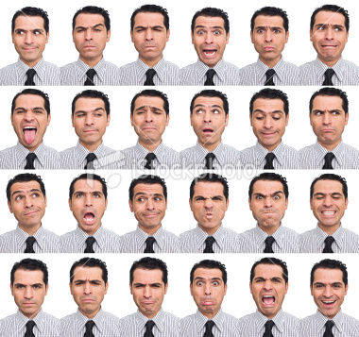

Not sure if it’s known how many facial expressions there are!

Muscles of the Human Face:

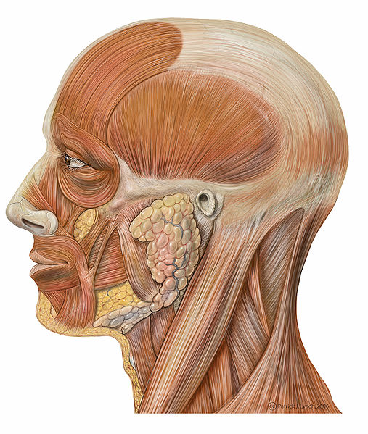

26 muscles to smile and 62 muscles to frown.

Notice the muscles on the head… can you wiggle your ears?